**CP Club 365 Days Challenge**

**Programming language – PYTHON**

**Problem Statement**

[https://practice.geeksforgeeks.org/problems/heap-sort/1?page=1&status[]=unsolved&curated[]=1&sortBy=submissions](https://practice.geeksforgeeks.org/problems/heap-sort/1?page=1&status%5b%5d=unsolved&curated%5b%5d=1&sortBy=submissions)

Git :- <https://github.com/Vedantbharad2603/CP_club_365_Days>

**Your Code**:

# 0x114Day of 0x365Days challenge

# VEDANT BHARAD

# 8-2-2023

class Solution:

    def heapify(self,arr, n, i):

        temp = i

        l = 2*i +1

        r = 2*i+ 2

        if l < n and arr[i] < arr[l]:

            temp = l

        if r < n and arr[temp] < arr[r]:

            temp = r

        if temp != i:

            arr[i], arr[temp] = arr[temp],arr[i]

            self.heapify(arr,n,temp)

    def buildHeap(self,arr,n):

        for i in range(n,-1,-1):

            self.heapify(arr,n,i)

    def HeapSort(self, arr, n):

        self.buildHeap(arr,n)

        for i in range(n-1,0,-1):

            arr[i],arr[0] = arr[0], arr [i]

            self.heapify(arr,i,0)

#{

# Driver Code Starts

#Initial Template for Python 3

import atexit

import io

import sys

# Contributed by : Mohit Kumara

_INPUT_LINES = sys.stdin.read().splitlines()

input = iter(_INPUT_LINES).__next__

_OUTPUT_BUFFER = io.StringIO()

sys.stdout = _OUTPUT_BUFFER

@atexit.register

def write():

    sys.__stdout__.write(_OUTPUT_BUFFER.getvalue())

if __name__ == '__main__':

    test_cases = int(input())

    for cases in range(test_cases):

        n = int(input())

        arr = list(map(int, input().strip().split()))

        Solution().HeapSort(arr,n)

        print(*arr)

# } Driver Code Ends

**Output (Screen Shot)**:

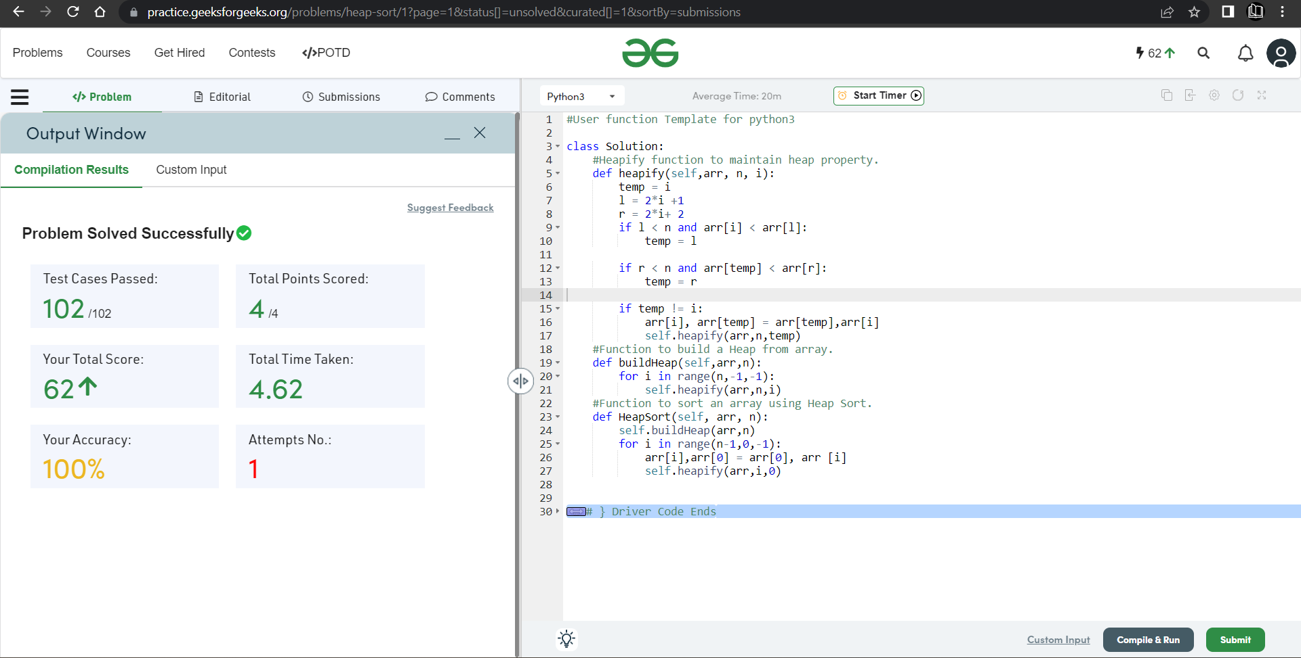

**Understanding about problem:**

* In this task I need to sort given array using Heap Sort.

Note: If you can't understand the problem, feel free to contact us and we'll help you. Please don't copy and paste from anywhere.

ALL THE BEST

Team CP Club